**When complete, this form must be emailed to Claire Bucholz (cbucholz@caltech.edu), Aleen Boladian (aleenb@caltech.edu), Mark Garcia (mgarcia@caltech.edu), and Julia Zuckerman (juliaz@caltech.edu). For class field trips, please also include Julie Lee. For research field trips, copy the PIs administrative staff.**
**Please fill in information about trip participants on the cover sheet at the begining of the safety plan template. If you are uncertain of their training status for driving, first aid, etc., you can check with Mark Garcia (mgarcia@caltech.edu) or Julia Zuckerman (juliaz@caltech.edu), who keeps records of training status. This cover sheet will be verified by the division staff and printed for the trip leader, along with participant emergency contact information.**

FIELD TRIP COVER SHEET
Instructor/Field Research Faculty Advisor:
Date(s) of Trip:
Course Number/Purpose:
Destination(s):
Vehicle Number(s): [Indicate “rental vehicle(s)”, “personal vehicle(s)”, “public transportation”, “boat travel”, or specify another transportation mode if not using GPS vehicles. If using GPS vehicles, division staff will fill in the vehicle numbers.]
Approved Driver(s):
Driving on Unpaved, Unmaintained Roads? [Yes/No]
Caltech Trip Participants [List below in alphabetical order by last name, providing the person’s position, any variance from the dates above, and if a consent form is required]
(In Alphabetical Order)  Last Name, First Name | Position at Caltech | Office Use |  |  |  | Variance (dates different from above/consent form required)
(In Alphabetical Order)  Last Name, First Name | Position at Caltech | Approved Driver? | Defensive Driving? | 4WD? | First Aid?* | Variance (dates different from above/consent form required)
 |  | ☐ | ☐ | ☐
 |  | ☐ | ☐ | ☐
 |  | ☐ | ☐ | ☐
 |  | ☐ | ☐ | ☐
 |  | ☐ | ☐ | ☐

Additional Information
- In order to participate in the trip, all trip participants must submit a contact information form available on the following link: https://www.gps.caltech.edu/academics/field-trips/contact-information-form-field-trips
- If someone is joining the field trip who is not a Caltech employee or fully admitted and enrolled Caltech student, they must submit both the contact information form online and a signed consent form to the Division Office. It is the responsibility of the trip leader to ensure that all those needing to submit signed consent forms have done so.
- Mark Garcia will provide vehicle numbers of GPS vehicles, confirm that listed drivers are approved, and fill in the training information.
    - For classes-related field trips defensive driver training must be taken every 2 years. Those requiring training can take the 1-hour class here: https://www.drivesafeonline.org/california/defensive-driving-course/
    - 4WD training is required for class-related field trips and recommended for research field trips when driving on unpaved, unmaintained roads. This training is to be taken once, with the option to take again after 4 years, if desired. The Division will organize an annual 4WD training for drivers on class field trips.
    - All training documentation, including first aid, must be sent to Julia Zuckerman (juliaz@caltech.edu). If you are uncertain of your last certification date, you may contact Julia for clarification.
- First Aid* = current certificate in first aid/CPR/AED, wilderness first aid, or emergency medical responder. For both class and research trips, all trip leaders should have a minimum of basic first aid training. This training is to be recertified after 2 years. First aid training is available through Caltech: https://emergencypreparedness.caltech.edu/training/CPRFirstAid. Wilderness First Aid training (WFA) is recommended for field trips when trip participants will be >1 hour from medical help at any time.
OVERVIEW
Field Site Location | Descriptive name of research location (e.g. Mojave Desert; Inyo Mountains). Attach a Google Earth image or topo map of the field site or itinerary to the safety plan. You do not need to list every stop on a field trip.
Activity Description | Type, length, and purpose of activity (e.g. collecting specimens, field mapping, etc.)
Plan Created for | Name of Research Group / Course |  | Date of revision |  | Mo-Day-Yr
Trip Leader | Name of Trip Leader | E-mail address |  | xxxxxx@caltech.edu
Phone number | Campus: (626) 395-XXXX; Mobile: (XXX) XXX-XXXX
Date(s) of Travel | Start date, duration, expected return to campus. List multiple dates if more than one trip is planned.

SITE INFORMATION
Location | Nearest City, State, Country (list multiple, if multiple locations will be visited)
Location | Latitude(s): XX.XXXX | Longitude(s): XX.XXXX
Site Access | Are there any particular restrictions or challenges to accessing site? Note any alternate routes or suggested parking areas; gate access codes, etc.
Security | High risk for harassment, violence, or robbery? Note intended mitigation measures and exit strategies.  **For international travel, check the U.S. State Department travel site for current travel alerts.  **While in the United States, international students and scholars should carry a physical document that demonstrates their evidence of registration at all times. Please refer to the Caltech International Offices’ guidelines to see which documents are required.
Expected Weather | Note extreme conditions that could impact the trip or require additional planning, (e.g. high heat, wind, rain, snow).
Drinking Water Availability | ☐ Plumbed water available  ☐ Potable water in jugs provided  ☐ Bottled water provided  ☐ Natural source and treatment methods (e.g. filtration, boiling, chemical disinfection):

TRAVEL
Mode of transportation | Will participants be traveling by car, plane, boat, etc. to site and during field activities.
Vehicle information | If traveling by vehicle, what type of vehicle will be used?
Travel at night? | Will travel at night occur?
Hazardous road conditions? | If traveling by vehicle, will there be hazardous road conditions? (e.g., dirt roads, 4WD required, mountain roads, etc.)
Alternative modes of travel | If alternative modes of travel (e.g., by ATV, boat, plane, livestock, etc.) what training is required of which trip participants and what participants have (or will obtain) the required training?

EMERGENCY SERVICES and CONTACT INFORMATION
Local Contact  (if applicable) | Name, address & phone #, may be a local colleague/institution, reserve manager, etc.  Lodging location: name, address, phone # | University Contact (optional)  Not on trip. Provide a copy of this plan. |  |  | Name, number, email; may be a Professor/PI, supervisor back on campus, colleague, etc.  Frequency of check ins: as necessary, daily, at end of work day, etc.
Nearest Hospital or Medical Clinic | Evacuation plan and transportation options to the nearest hospital or medical clinic; include estimated transport time, contact information and driving directions from the site to the nearest provider of emergency medical care.
Cell Phone Coverage | Primary Number:  Coverage: Carrier? good, spotty, none |  | Satellite phone or inReach device | Device carried? ☐yes ☐no  Type/number:  Division Satellite Phone #s:  ☐ 881651455634  ☐ 881622445739
Nearby Facilities | What facilities are available at or near the site: restrooms, water, gas, public phone, store? If not, where are the nearest services along the route?
GPS Division Emergency Contact Information | Caltech Safety Office (626) 395-5000

PARTICIPANT INFORMATION
Field Team/ Participants | Is anyone working alone? ☐ Yes ☐ No  If yes, develop a communications plan with strict check-in procedures; if cell coverage is unreliable, carry a satellite communication device or personal locator beacon.  Primary Field Team Leader: Name  Secondary Field Team Leader: Name, phone number  ☐ Field Team/Participant list is attached
Physical Demands | List any physical demands required for this trip and training/certification provided. e.g. diving, swimming, hiking, climbing, high altitudes, respirators, heights, confined or restricted spaces, etc.
Mental Demands | List any unique mental demands required for this trip, e.g. long travel days, high stress environments, different cultural norms, etc.
First Aid Training  & Supplies | List trip leader(s)’ first aid training. On the cover sheet of the field safety plan, please list first aid training received for all participants. (See cover sheet and field safety protocols document on division website for requirements)  Location and description of group medical/first aid kit (provided and stocked by Division):  Who is carrying it, where is it stored.
Required specialized training? | Is any pre-trip/activity specialized training required (e.g., drilling, being on a research vessel, using toxic chemicals?)
Immunizations or Medical Evaluation | List required immunizations/prophylaxis or required medical evaluation, if applicable.
Personal Protective Equipment | Required—e.g. N95 masks, boots, ear plugs, safety glasses, PFDs, hardhats, etc.  Recommended – e.g. walking sticks, long pants, hats, insect repellant, sunscreen

RISK MITIGATION
Identified Risks/Hazards  (from Risk Assessment) | RAC Score (Pre-mitigation) | Controls/Mitigations | RAC Score (Post-mitigation)
1.
2.
3.
4.
5.
6.
7.
8.
9.
10.
Average RAC of all hazards |  | Average RAC of all hazards

Signature of Trip Leader:
By signing below the trip leader verifies that they have shared the contents of this safety plan with all team members and that they are familiar with the risks, prevention measures, and emergency plans
Name | Signature | Date

When completing the online contact information form which is required for participation of the field trip (see links below) trip participants will verify that they have reviewed the Field Safety Plan. Inherent in this verification, participants are verifying that they contributed to the development of the field safety plan, had the ability to raise amendments and modify the field safety plan, understand its contents, and agree to comply with its requirements. Although the above plan has attempted to identify risks and plans to mitigate them (if possible), there are always unforeseeable risks and the above safety plan will undoubtedly be incomplete. Trip participants acknowledge that safety is everyone’s responsibility and accept the risks of the trip.
Field Trip Contact Information Form

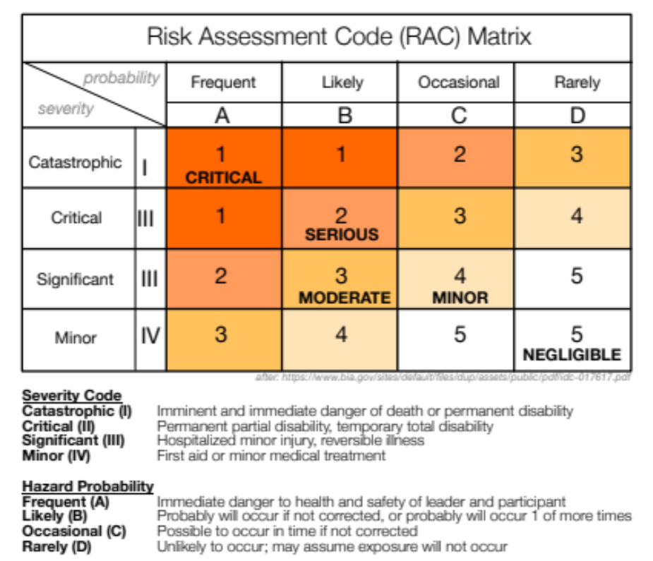
RISK MITIGATION (COMMON EXAMPLES)
Identified Risks/Hazards  (from Risk Assessment) | RAC Score (Pre-mitigation) | Controls/Mitigations | RAC Score (Post-mitigation)
1. Car travel | 3 | Drivers must have defensive driving training and obey traffic laws. Drivers and passengers must wear seatbelts inside moving vehicle. | 3
2. Sunburn | 4 | Wear long sleeves/pants, hat, and sunscreen with SPF ≥30 | 5
3. Heat stress due to high temperatures | 3 | Conduct heath illness prevention training. Acclimate gradually. Carry sufficient water, drink plenty of liquids, and take frequent breaks in shade. Carry a shade structure is necessary. Continually monitor worksite conditions. | 5
4. Animal- or insect-borne local diseases | 4 | Do not touch wild animals or rodent feces, and wear long sleeves/bug spray to avoid insect bites | 5
5. Rugged terrain | 3 | Wear sturdy boots with support, carry hiking poles if useful, and carry as light of a pack for day work as possible | 5
6. Hammering on rocks | 3 | Use proper PPE (safety glasses, gloves, ear plugs). Take frequent breaks to avoid repetitive use injuries. | 5
7. Airborne dust (risk of Valley Fever) | 4 | N95 masks will be made available to all participants. Wind conditions will be monitored. If dusty condition arise, participant will be asked to wear masks and field activities will be modified to limit exposure to dust. | 5
Average RAC of all hazards | 3.3 | Average RAC of all hazards | 4.7

Example of Risk Mitigation Assessment:
The RAC matrix is intended to help leaders and participants on field trips develop and implement effective safety practices to reduce risk. Inherently, there is some subjectivity to how risks are assessed in terms of their severity and frequency. Further, it is acknowledged that trip leaders and participants are not risk assessment experts or trained in risk assessment. In addition, there may be multiple levels of severity and frequency associated each identified risks. The field safety committee suggests that worse case scenarios (highest severity and frequency) be assumed for sake of consistency.
Here, we first use driving a vehicle is used as an example. Above, it is rated as a 3 pre-mitigation because catastrophic (or lesser) injuries can rarely happen (worse case scenario). Upon implementing the controls/mitigations described, although the risk of critical injuries will be diminished, they may still rarely happen, so the post-mitigation score remains 3.
Next, we can consider the risk of hammering on rocks. A critical injury from flying rocks or repetitive use injuries can occasionally happen resulting in a score of 3. However, after implementing proper PPE and taking frequent breaks, the severity code drops to being minor injuries only occasionally happening, resulting in a score of 5.
Again, it is stressed, that the RAC matrix should be used as a tool to develop effective mitigation measures and should not be an onerous undertaking on deciding exactly the correct number for each risk. The important point is that the scores increase for each risk whenever possible.

